18 ADSL Brætspilsaften 24/02- KBH

| Bong 1 |  | 193,70 kr |
| --- | --- | --- |
| Bong 2 Pizza |  | 1005,00 kr |
|  |  |  |
| Total |  | 1198,70 |

Bong 1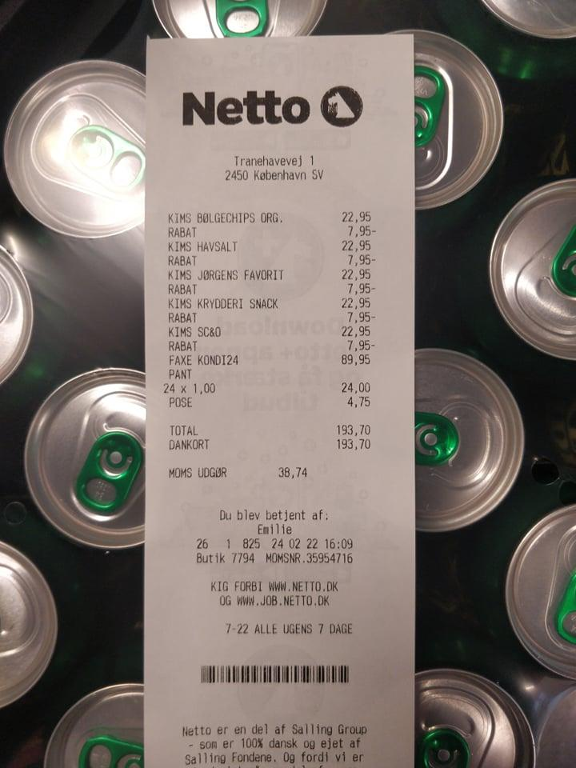

Bong 2